|  |  |  |  |
| --- | --- | --- | --- |
|  |  | CESL ERP  ARCHITECTURE  Harshan Nishantha / 2025.04.10 / v 1.0 |  |
|  |  |  |  |
|  | | | |



Table of Contents

1

Harshan Nishantha / 2025.04.10 / v 1.0 1

1

1.0 INTRODUCTION 3

2.0 Architecture DIAGRAM 4

2.1 CESL ERP UI 5

2.2 Backend Microservice Modules 6

2.3 CESL.ERP.Core.Function 7

2.4 CESL.ERP.Projects.Function 7

2.5 CESL.ERP.Notifications.Function 7

2.6 CESL.ERP.HRM.Function 7

2.7 CESL.ERP.Security.Sdk 7

2.8 CESL.ERP.Shared 7

2.9 FRM Database 8

2.10 ERP Database 8

|  |  |  |
| --- | --- | --- |
| 1.0 INTRODUCTION |  | |
| Central Engineering Services (Pvt) Ltd (CESL) Enterprise Resource Planning (ERP) software solution is designed to actively manage and maintain day to day operations in an effective manner. This document contains the architectural aspects of the newly designed software system. New system expects to address difficulties faced in old ERP system, leverage latest technology to increase performance and reliability, introduce responsive user-friendly UI to the system which renders nicely in mobile devices, introduce better software practices to the development team and enhance usability by re-designing modules. | |  |
|  | |  |
|  | |  |

|  |  |
| --- | --- |
| 2.0 Architecture DIAGRAM |  |

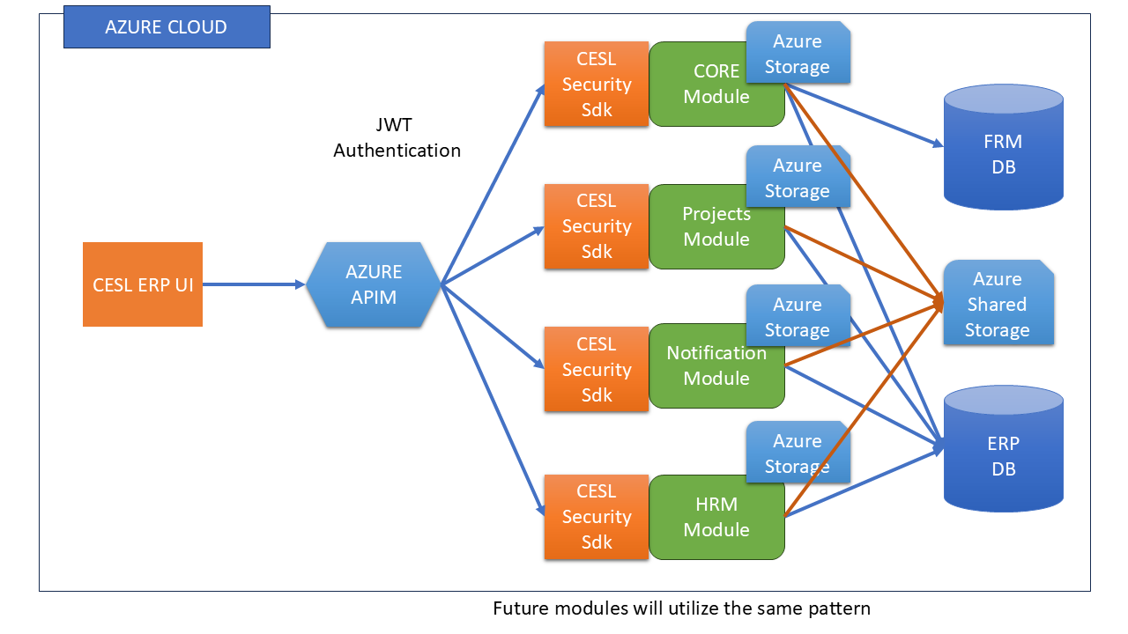

CESL ERP system consist of several parts. All the components will be hosted in Microsoft Azure environment. Application is designed based on microservices architecture. These components are connected via Azure Virtual Network (VNET)

## 2.1 CESL ERP UI

CESL ERP UI is the frontend of the application. This application uses Next.js (<https://nextjs.org/>) and React ([https://react.dev/)](https://react.dev/)%20) technologies. Application is organized based on component-based architecture. This application connects with Azure API Management (APIM) endpoints to communicate with backend services. Backend services authentication and authorization is handled via JWT Tokens. Visual Studio Code IDE ([https://code.visualstudio.com/)](https://code.visualstudio.com/)%20) is used for the development of the application.

Currently this application is deployed in cesl virtual machine in Azure and IIS reverse proxy has defined to map to the <http://ceslerp.lk/v2> url.

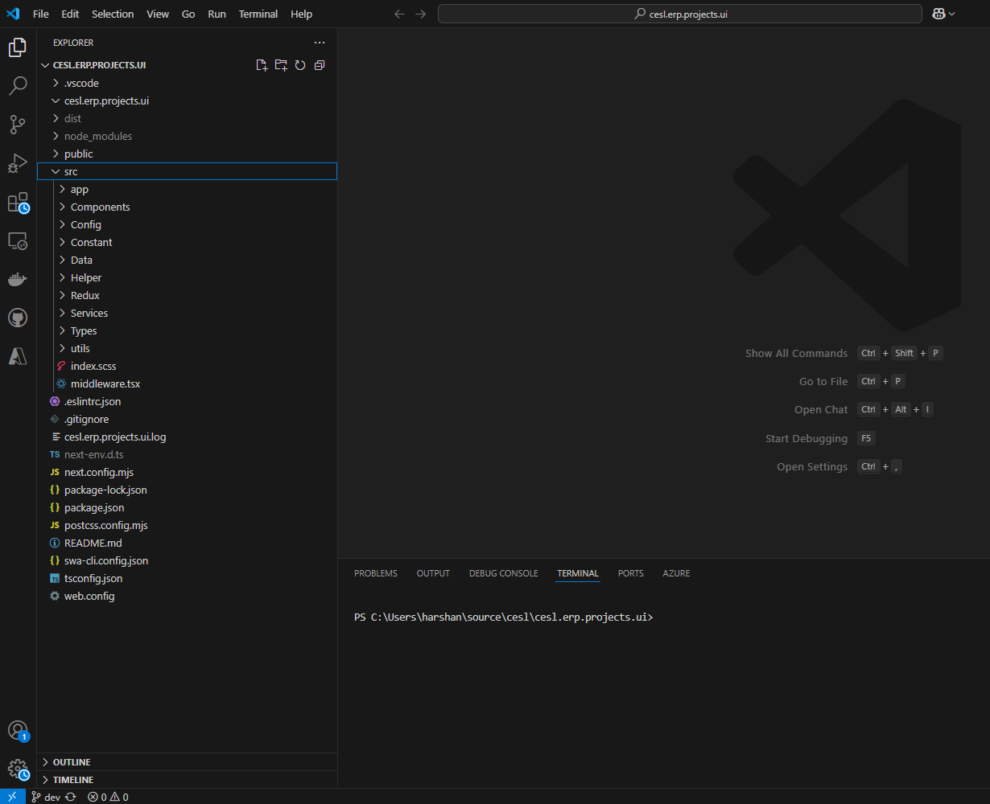

## 2.2 Backend Microservice Modules

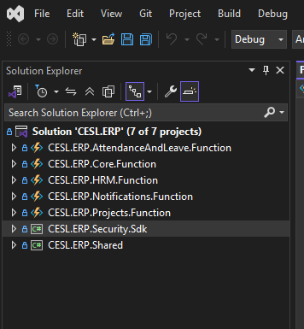

There are several backend modules like CORE module, Projects module, etc…. These modules have defined based on the consideration of functionality, security and scalability aspects. Backend modules are developed as microservices. Azure functions are used as backend APIs. The functions in the backend are exposed to frontend via Azure APIM only. These applications use a shared library (CESL.ERP.Shared) which is a library with shared functionality between modules and CESL security library (CESL.ERP.Security.Sdk) which handles security of the systems. A shared Azure storage account is used to trigger notifications and save attachments. Every function app has own storage account for saving state and store Azure data.

Visual Studio 2022 IDE ([https://visualstudio.microsoft.com/vs/)](https://visualstudio.microsoft.com/vs/)%20) has used for the application development and all the applications currently use .NET 8 and C#. For database handling Entity Framework Core framework is used.

All the microservices modules are hosted as Azure function apps and these apps are assigned with own Azure application insights instance for monitoring purpose.

## 2.3 CESL.ERP.Core.Function

CESL.ERP.Core.Function is an Azure function microservice application which handles shared functionality between modules. This application also contains the token endpoint which is used to issue tokens for users. This is the only function app which access the security database (FRM Database).

## 2.4 CESL.ERP.Projects.Function

This is another Azure function microservice application. This application handles Job Code and Business Segment manipulation and suppliers’ manipulation requirements.

## 2.5 CESL.ERP.Notifications.Function

This is also an Azure function microservice application. This is the common notification module used by the system. Notification module listen to an Azure storage queue in shared storage account and other modules can leverage this queue to trigger notifications. This application has standalone reusable functionality to send notifications via email. We expect to extend the functionality of this module to send SMS, WhatsApp and other messages as well.

## 2.6 CESL.ERP.HRM.Function

This Azure function microservice application handles HR aspects of the system. Employees registration and manipulation done via this module.

## 2.7 CESL.ERP.Security.Sdk

This is a C# library and this library is shared by all other applications. This is the only library that connects with security database (FRM Database) and this library contains the all the security helpers including token issuing and validation.

## 2.8 CESL.ERP.Shared

This is also a C# library and this library contains the shared code with other applications.

## 2.9 FRM Database

This is the security database of the system. This is a MSSQL database and this database contains all the user details and user scope details.

## 2.10 ERP Database

ERP database is the general database used to store application data. All the applications store data in this database. This is a MSSQL database.